**Long Short-Term Memory (LSTM)**

is an enhanced version of the [Recurrent Neural Network (RNN)](https://www.geeksforgeeks.org/introduction-to-recurrent-neural-network/) designed by Hochreiter and Schmidhuber. LSTMs can capture long-term dependencies in sequential data making them ideal for tasks like language translation, speech recognition and time series forecasting.

Unlike traditional RNNs which use a single hidden state passed through time LSTMs introduce a memory cell that holds information over extended periods addressing the challenge of learning long-term dependencies.

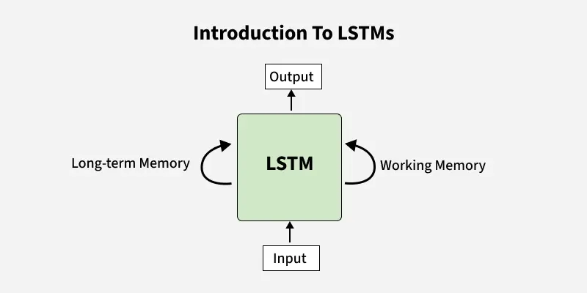

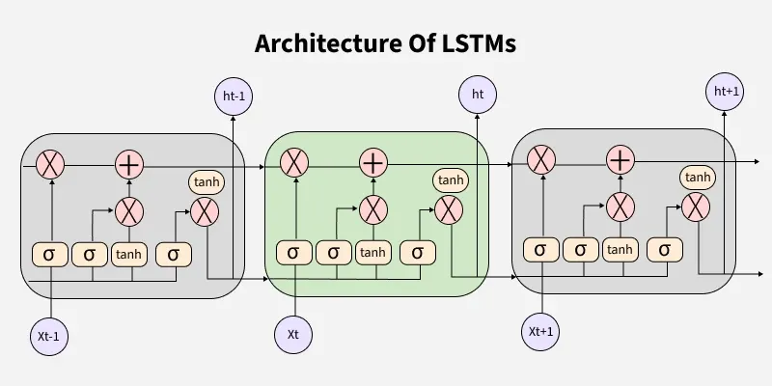

## **Problem with Long-Term Dependencies in RNN**

Recurrent Neural Networks (RNNs) are designed to handle sequential data by maintaining a hidden state that captures information from previous time steps. However they often face challenges in learning long-term dependencies where information from distant time steps becomes crucial for making accurate predictions for current state. This problem is known as the vanishing gradient or exploding gradient problem.

* **Vanishing Gradient**: When training a model over time, the gradients which help the model learn can shrink as they pass through many steps. This makes it hard for the model to learn long-term patterns since earlier information becomes almost irrelevant.
* **Exploding Gradient**: Sometimes gradients can grow too large causing instability. This makes it difficult for the model to learn properly as the updates to the model become erratic and unpredictable.

Both of these issues make it challenging for standard RNNs to effectively capture long-term dependencies in sequential data.

## **LSTM Architecture**

LSTM architectures involves the memory cell which is controlled by three gates:

1. **Input gate**: Controls what information is added to the memory cell.
2. **Forget gate**: Determines what information is removed from the memory cell.
3. **Output gate**: Controls what information is output from the memory cell.

This allows LSTM networks to selectively retain or discard information as it flows through the network which allows them to learn long-term dependencies. The network has a hidden state which is like its short-term memory. This memory is updated using the current input, the previous hidden state and the current state of the memory cell.

## **Working of LSTM**

LSTM architecture has a chain structure that contains four neural networks and different memory blocks called cells.

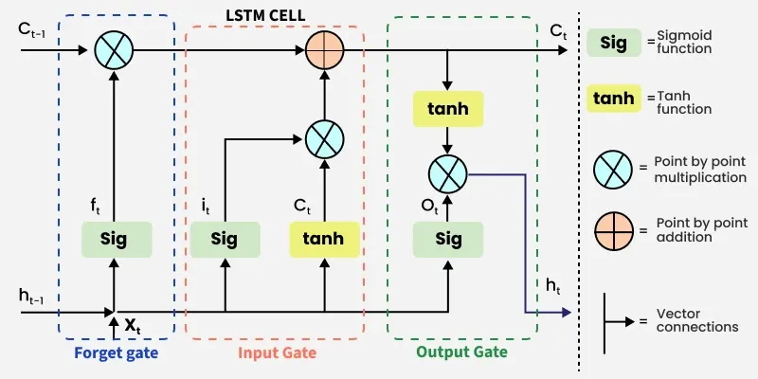*LSTM Model*

Information is retained by the cells and the memory manipulations are done by thegate

**1. Forget Gate**

The information that is no longer useful in the cell state is removed with the forget gate. Two inputs Xt(input at the particular time) and *ht*−1(previous cell output) are fed to the gate and multiplied with weight matrices followed by the addition of bias. The resultant is passed through an activation function which gives a binary output. If for a particular cell state the output is 0, the piece of information is forgotten and for output 1, the information is retained for future use.

The equation for the forget gate is:

s**.** There are three gates -

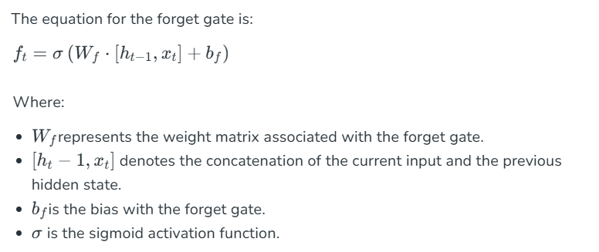

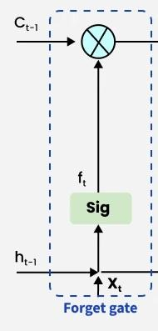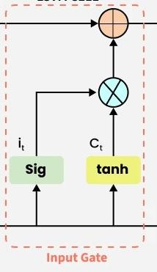

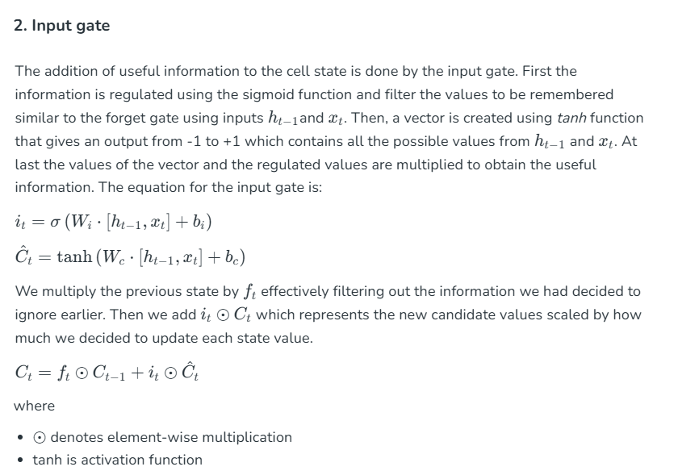

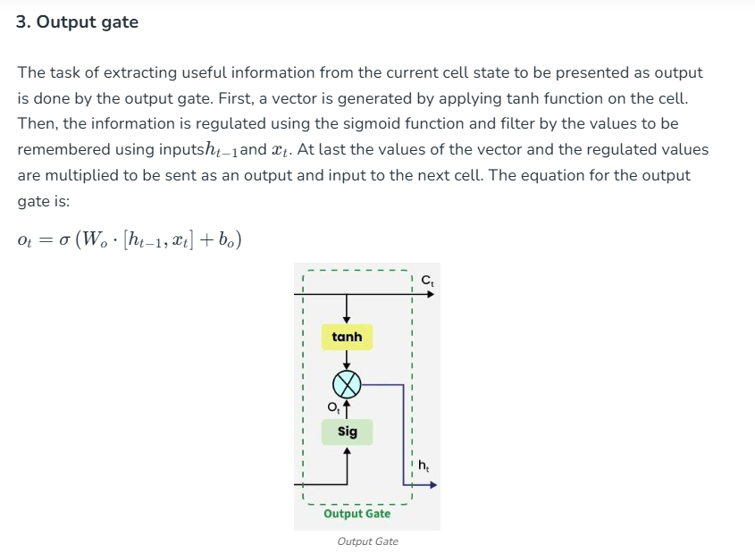

## **Applications of LSTM**

Some of the famous applications of LSTM includes:

* **Language Modeling**: Used in tasks like language modeling, machine translation and text summarization. These networks learn the dependencies between words in a sentence to generate coherent and grammatically correct sentences.
* **Speech Recognition**: Used in transcribing speech to text and recognizing spoken commands. By learning speech patterns they can match spoken words to corresponding text.
* **Time Series Forecasting**: Used for predicting stock prices, weather and energy consumption. They learn patterns in time series data to predict future events.
* **Anomaly Detection**: Used for detecting fraud or network intrusions. These networks can identify patterns in data that deviate drastically and flag them as potential anomalies.
* **Recommender Systems**: In recommendation tasks like suggesting movies, music and books. They learn user behavior patterns to provide personalized suggestions.
* **Video Analysis**: Applied in tasks such as object detection, activity recognition and action classification. When combined with [Convolutional Neural Networks (CNNs)](https://www.geeksforgeeks.org/introduction-convolution-neural-network/) they help analyze video data and extract useful information.